Skills Training Grants (STG) User Guide

**Community Workforce Response Grant Participant Early Withdrawal Reporting**

**Last Updated:** April 25, 2025

1. Log into the [Skills Training Grants page](https://communityworkforceresponsegrants.gov.bc.ca/) with your BCeID.
2. Scroll down the page to your Community Workforce Response Grant (CWRG) application, then click “Continue.”

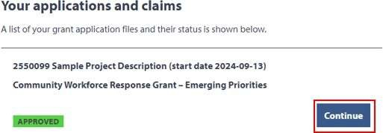

1. Click “View Participant List”

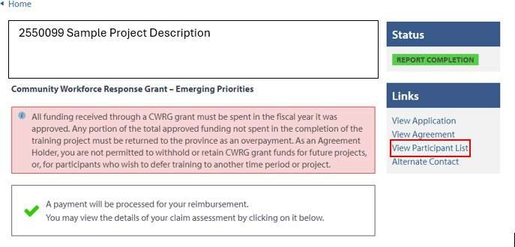

1. Locate participant name to report as withdrawn, scroll to the right, and click “Report Withdrawal”

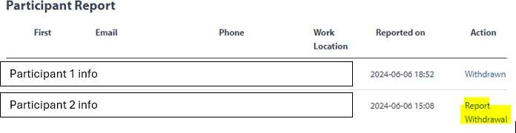

1. A pop-up window will appear. Make sure the correct participant has been selected and click “Yes”. Note this action cannot be reversed.

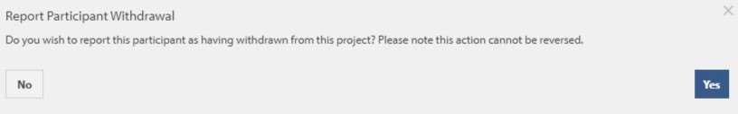

1. Copy the provided link and forward to withdrawn participant

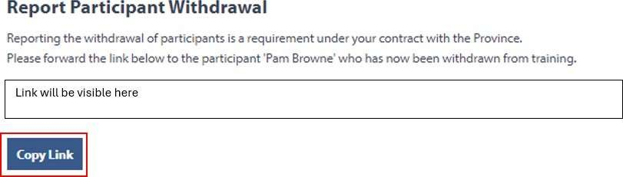

Note: If you would like to include a short description to participants along with the e-mailed link, here is a recommended template:

Dear XXXX,

You have chosen to withdraw from the following training program:

Program Name:

Start Date:

Withdrawn Date:

As this training is being funded through the Community Workforce Response Grant (CWRG), we kindly ask you to complete the “Participant Early Withdrawal Form” using the following link:

(copy and paste link from STG)

The form will be used to provide the CWRG team with feedback on your early withdrawal from the training program.

To ensure your privacy, once completed, the form is submitted directly and confidentially to the CWRG only. Kind Regards,

(Your signature)

7. When you return to your participant report, you should now see participant as “Withdrawn”

