Skills Training Grants (STG) User Guide

Applying for Employer Training Grants (ETG)
Last Updated: 26 August 2023
- Log into the Skills Training Grants page with your BCeID.

- Click “Start New B.C. Employer Training Grant Application”.
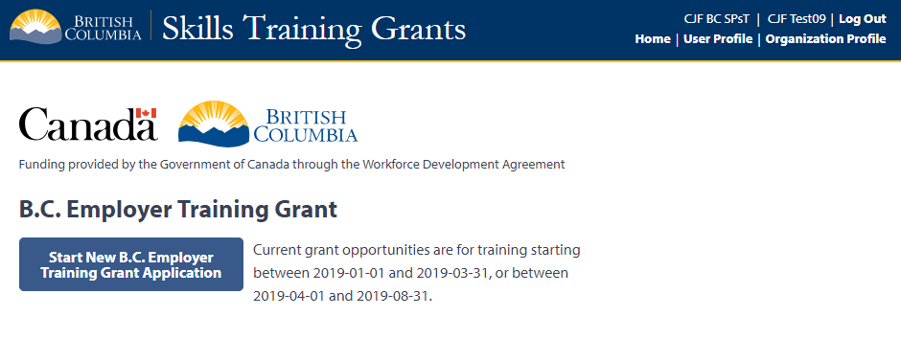
- Click the radial button for the grant stream you want to apply under. Click “Show Description” for more details about a grant stream.
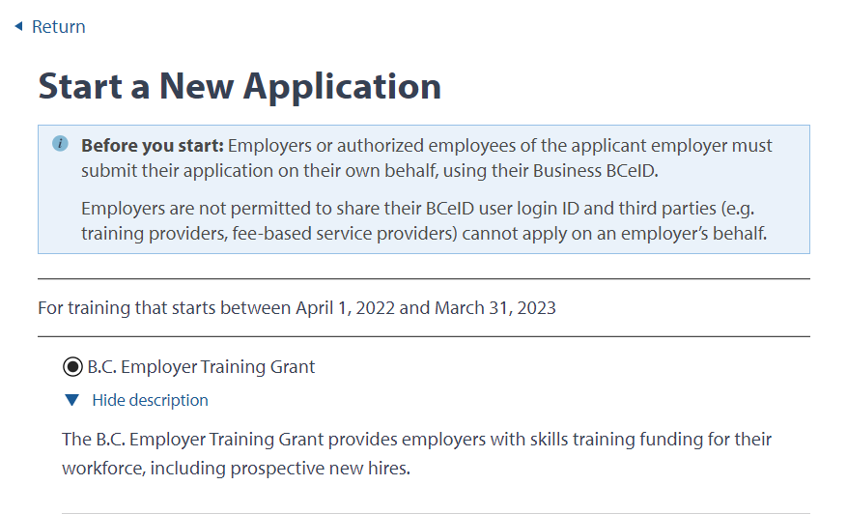

- Select the Delivery Start & End Dates for your program. Answer the question about the forest sector, then click “Continue”.
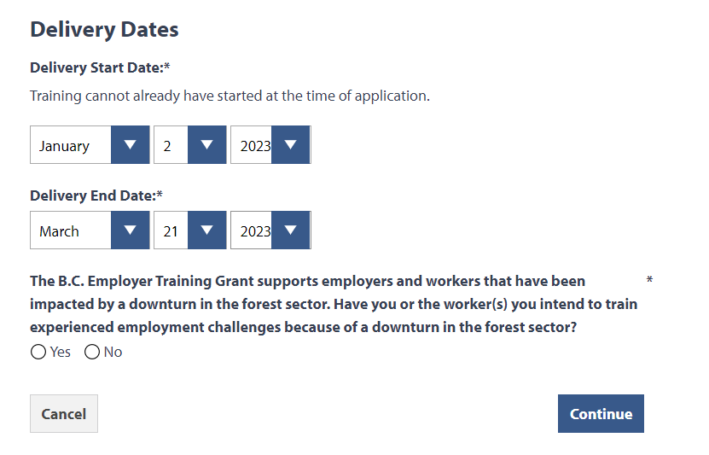
Answer the question. If yes, a text box will appear for you to add more details.
Click “Continue”.
The end date must be within 1 year of the start date.
- Click “Edit” beside “Training Program”.
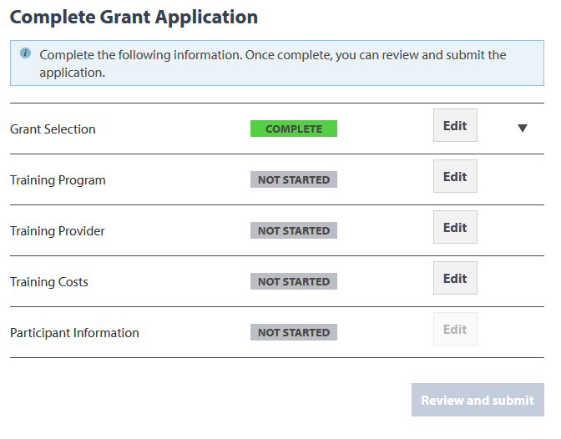
- Go through the form, filling out all fields. Once you’re finished, click “Done”.
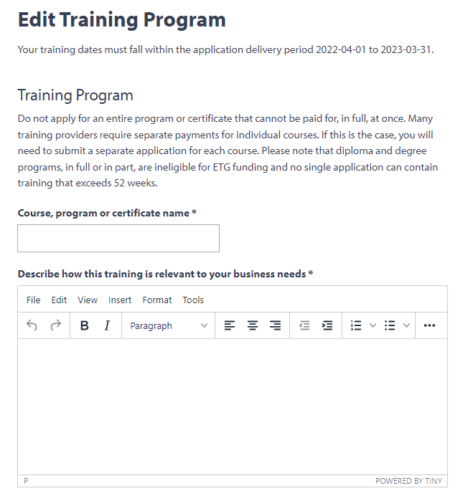
Copy and paste from another document or format text up to 2000 characters for each question.
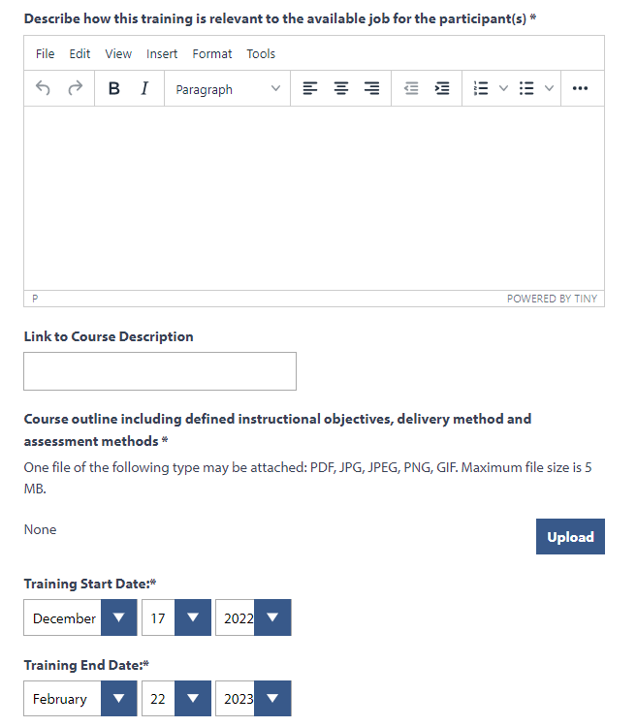
Click “Upload” to add the course outline.
The training dates are automatically added based on the dates you selected when you started the application. You may edit them here if needed.

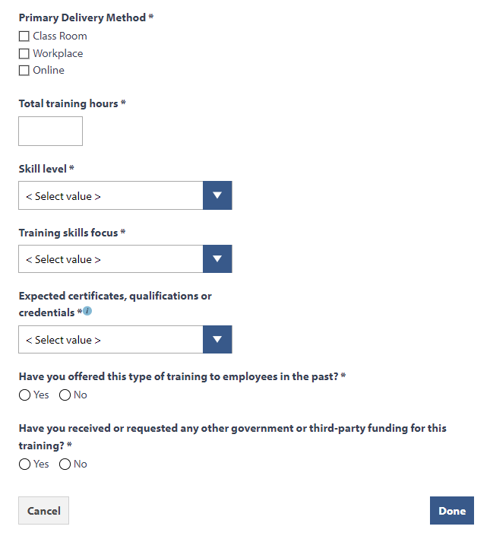
Click “Done”.
- Click “Edit” beside “Training Provider”.
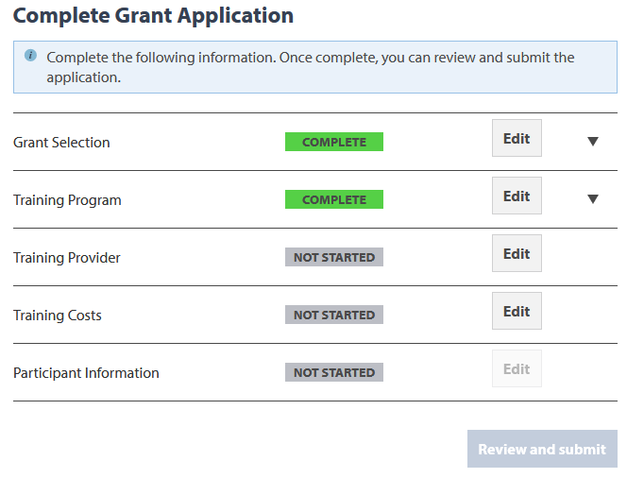

- Go through the form, filling out all fields. Once you’re finished, click “Done”.
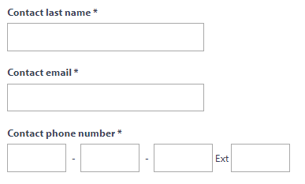
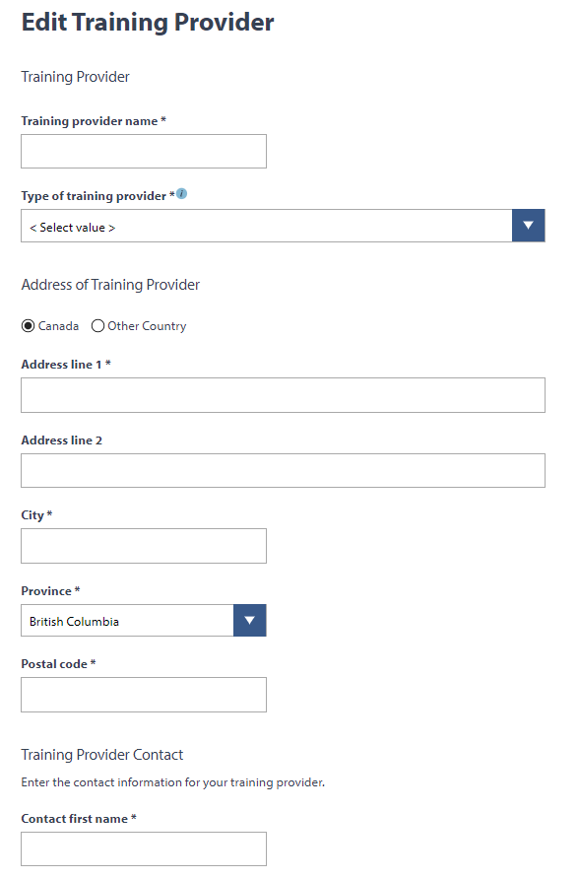
If the training provider is located outside of British Columbia, the box below will appear. Write your response to the question in the space provided.
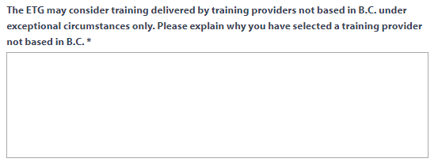

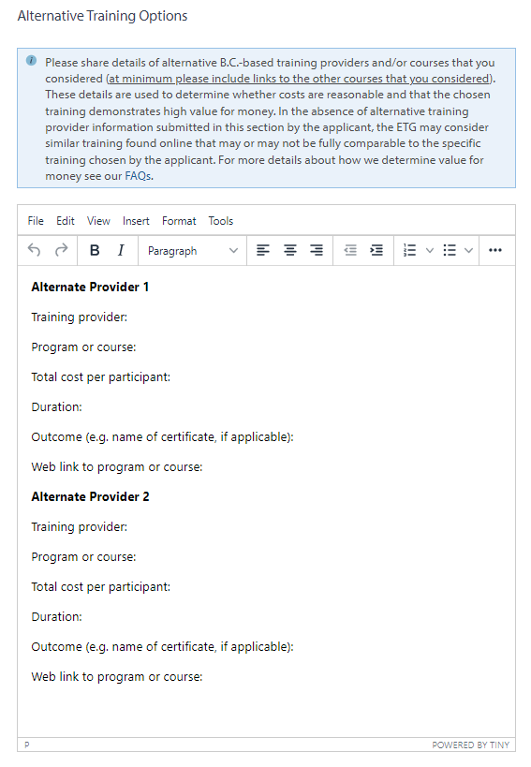
Fill in the prepopulated text and any additional information needed.
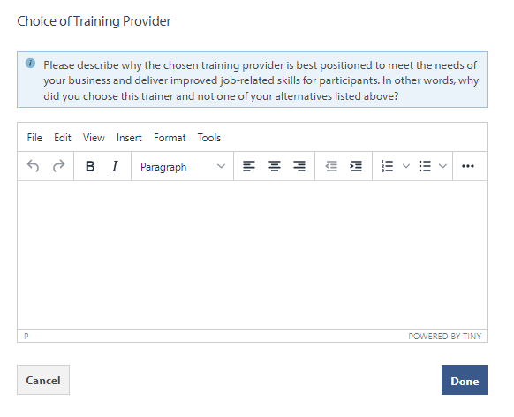
Copy and paste from another document or format text up to 2000 characters.
- Click “Edit” next to “Training Costs”.
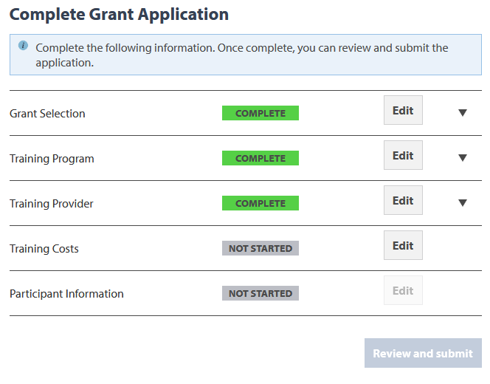
- Enter the number of expected participants, then click “Add New Expense Type”.
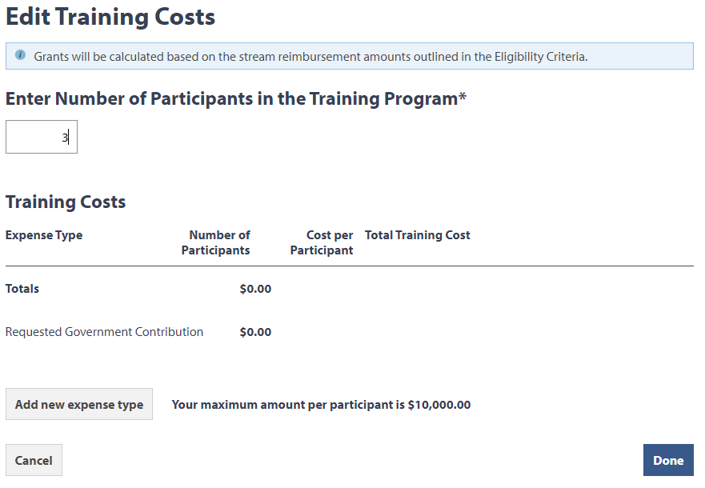
- Choose an expense type from the drop-down list, then fill out the rest of the fields. Once you’re finished, click “Save Expense”.
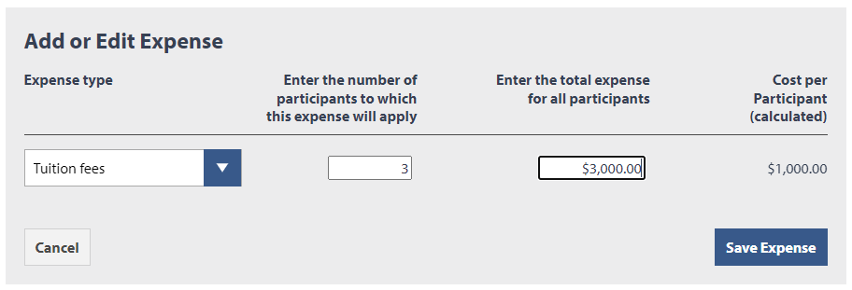

- Please note that if you add travel related expenses you will be asked to upload required documents.

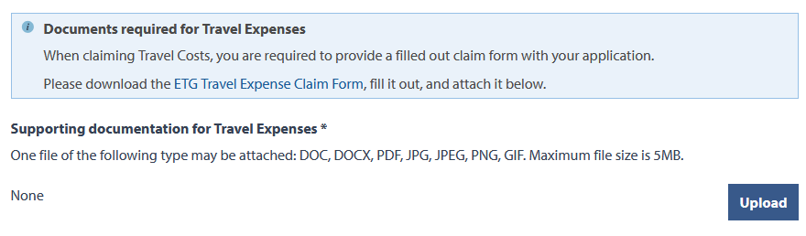

- Add more expense types as needed. If you need to make any changes, click “Edit” or “Delete” beside the expense. Once you’re finished entering your expenses, click “Done”.

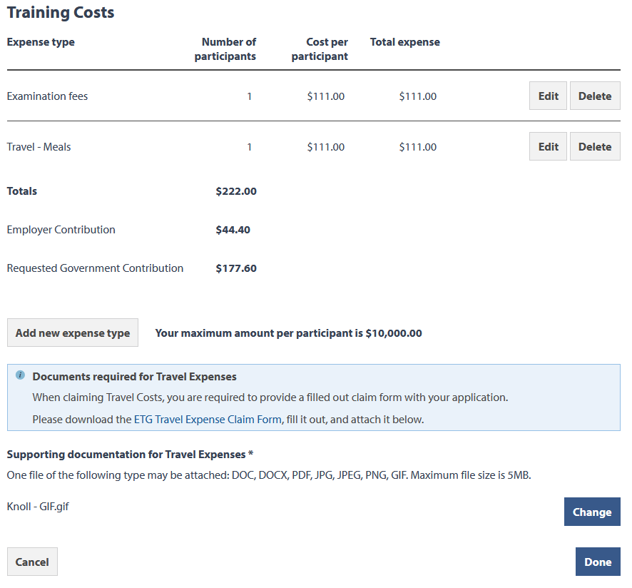

- You can complete participant reporting by selecting “Edit” beside “Participant Information”. All participant information forms (PIFs) must be completed before you can submit the application.

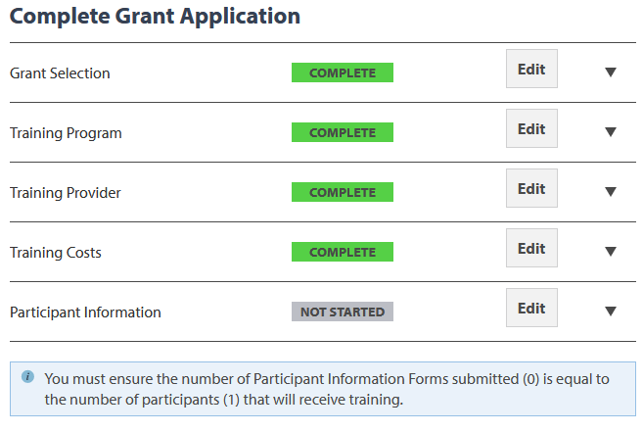

- Click “Add participant details”. Here, you will be able to enter details such as first name, last name, email, and expected job outcome. Once you’re finished entering participant details, click “Save”.

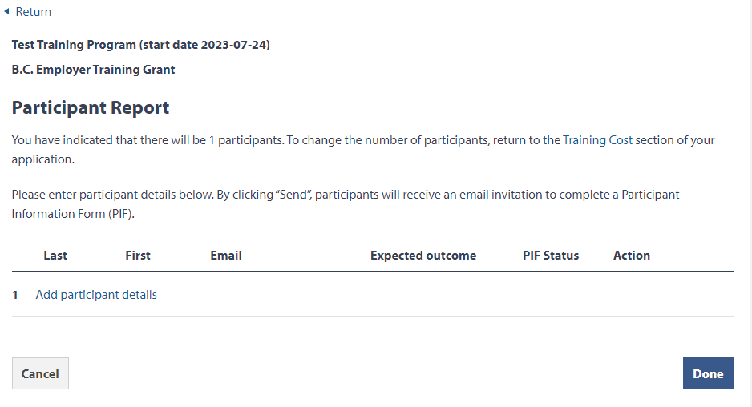
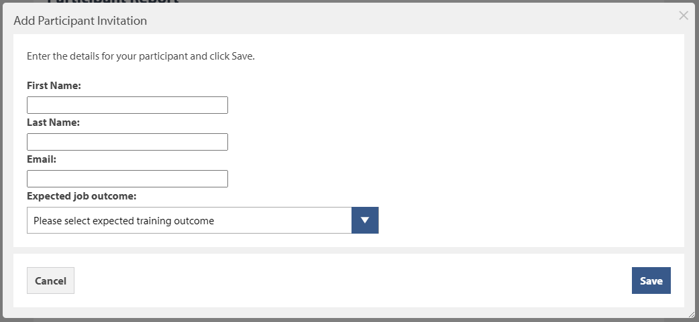

- Once participant details have been entered you can click “Send”, participants will receive an email invitation to complete a Participant Information Form (PIF). To remove a participant that was entered by mistake click “Remove”.
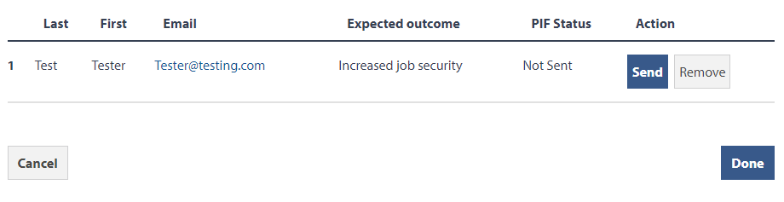
If you need to remove a participant, click “Remove”.
- If not all PIFs have been completed the status will show “In Progress” along with a message stating that not all PIFs are submitted. Click “Edit” in the Participant Information section to continue sending out email invitations for remaining participants to complete.
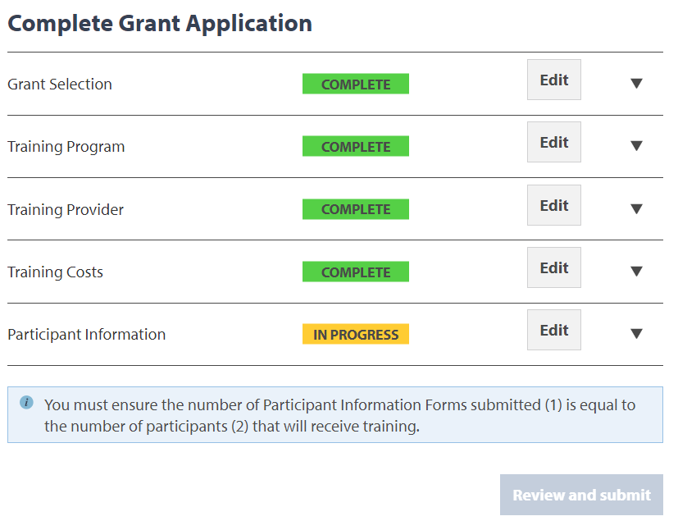

- You are now ready to review and submit your application. NOTE: The status of the application states, “Not Submitted”. Click “Review and submit”.

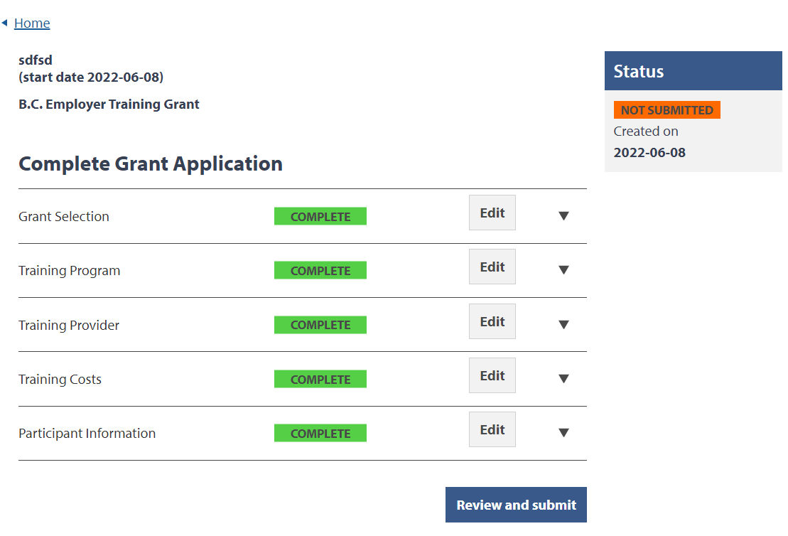

- Go through Step 1 of the form and review your details. Click the “Edit […]” buttons to make any changes, then click “Continue” to go to the next page.

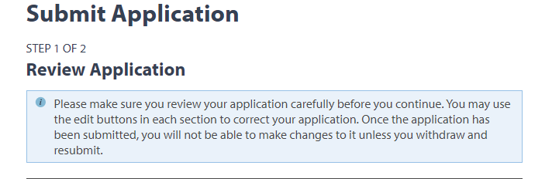

- Once you’ve reached Step 2, click the “By checking this box I make this declaration” checkbox, then click “Submit application”.

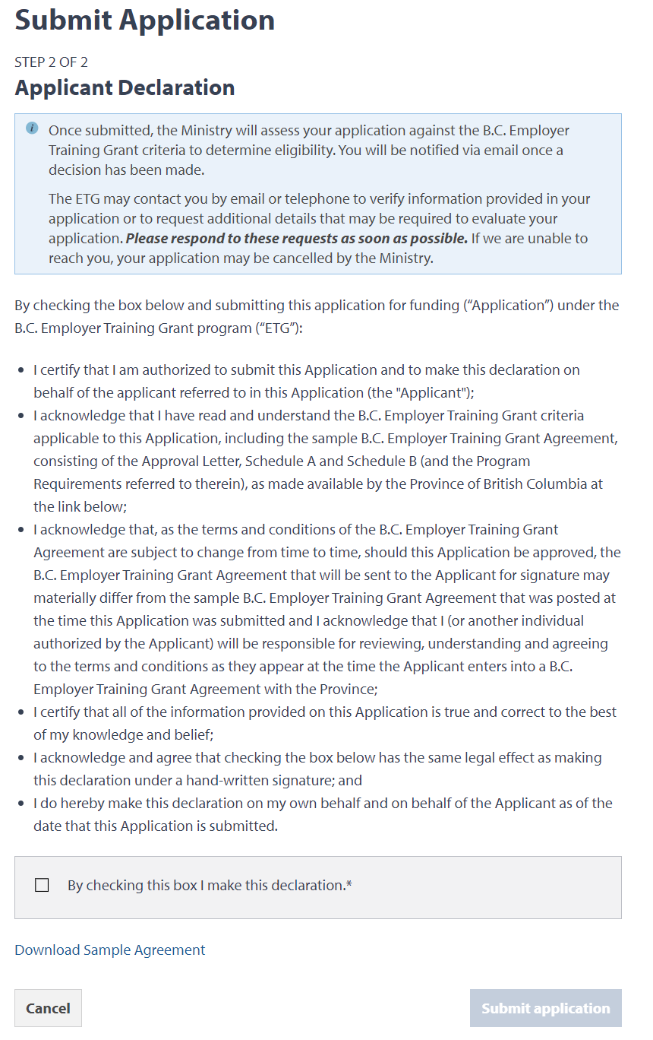

- Your application is now submitted. You will see the application in a “Complete” status on the home page. The program area will review it and send you an email with your next steps.

